**Operating Systems Lab**

**Fall 2024**

**Lab Task 08:**



**Name: Farwa Rashid**

**Sap : 45945**

**BSCS 5 SEMESTER**

**Lab Instructor:**

**Kausar Nasreen Khattak**

**Lab Task**

**Note:** Include screenshots, required to illustrate your explanation for all Questions.

Q1: Write a C/C++ program that uses the fork() function and the logical AND (&&) operator.

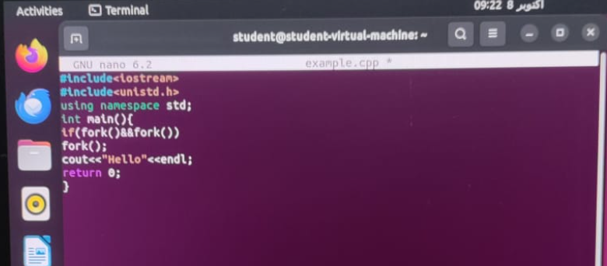

When using the AND operator, both conditions must be true. The first fork() call creates a child process : 0 and a parent process : 1. The second fork() is executed by the parent process, while the child process terminates. The parent is then split again into a new child and the parent. Lastly, the final fork() is called only by the parent process (since 1+1 is true), where the new child terminates, and the parent is once again divided into a child and parent. As a result, "hello" is printed twice.

Q2: Write a C/C++ program that uses the fork() function and the logical OR (II) operator.

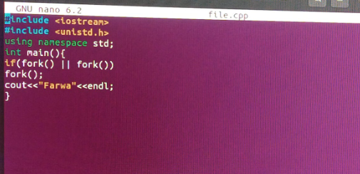

When using the OR operator, if any condition is true, the result will be true, and the program proceeds. In the case of fork(), it means creating a new child process. The first fork() creates a child :0 and a parent : 1. The second fork() is executed by both the parent and child . The parent is then split again into a new child and a parent , while the child is also split into two more child processes (both = 0). Since one condition in the child process ( = 1) is true (0+1 = true), another fork() occurs, splitting it further into two child processes (both = 0). This is the final fork() call, resulting in "hello" being printed four times.

Q3: Write a C++ program that uses fork() to create a child process. Use an if-else statement.

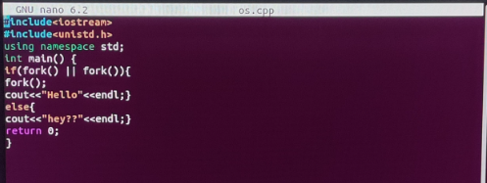

In this program we have used AND operator with if else case means if case fork fails then else case will run. AND the operator will work if one of the conditions is false it will false.